Bangladesh Medical Association (BMA)
List of Life Member-20
52. BMA Patuakhali Branch

Sl No | Voter No | Voter Details
1 | Voter No  LM-5200001  No Image | DR. MIRZA AHMED  F/Name:  M/Name:  BM & DC Reg. No:  NID:  Cell: 01711904701  Address: Thana Health Complex  Mirzagonj  Patuakhali  Blood Group: O+
2 | Voter No  LM-5200002  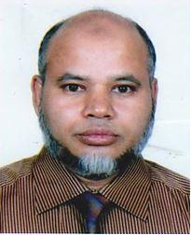 | DR. K.M. JALAL UDDIN AHMED  F/Name: Kazi Azahar Uddin  M/Name:  BM & DC Reg. No: 20934  NID:  Cell:  Address: Managing Director Patuakhali Clinic 24, Kazipara, Patuakhali  Blood Group: O+
3 | Voter No  LM-5200003  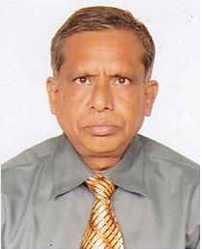 | DR. MIZANUR RAHMAN  F/Name: Md. Abdul Haque  M/Name:  BM & DC Reg. No:  NID:  Cell:  Address: Pathologist  General Hospital  Patuakhali  Blood Group:
4 | Voter No  LM-5200004  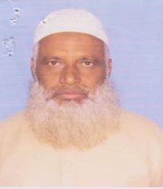 | DR. A.K.M. ABUL KHAIR  F/Name: M.a. Salam Miah  M/Name:  BM & DC Reg. No:  NID:  Cell:  Address: Medical Officer, Civil Surgeon Office  Patuakhali.  Blood Group:
5 | Voter No  LM-5200005  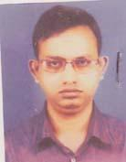 | DR. MD. ABU ABDULLAH  F/Name: Md. Yunus Miah  M/Name: Hamida Begum (late)  BM & DC Reg. No: 33347  NID: 0422801100974  Cell: 01732559057  Address: The Apollo Hospital (Pvt), PTI Road, Pathuakhali.  Blood Group: A+
6 | Voter No  LM-5200006 | DR. ROMMANA SAYLA NUR  F/Name: A.k.m. Nurul Islam  M/Name: Late Akter Nahar Begum  BM & DC Reg. No: 25897  NID: 7829508132647  Cell: 01819160699  Address: Asst. Registrar, 250 Beded Hospital, Patuakhali.  Blood Group: A+
7 | Voter No  LM-5200007 | DR. MD. MAHMUDUR RAHMAN  F/Name: Late Azaher Ali Hawlader  M/Name: Mst. Zohora Khatun  BM & DC Reg. No: 12480  NID: 7829504114564  Cell: 01711368485  Address: Senior Con Sultant, Gynae 250 Bedded Hospital, Patukhali.  Blood Group: O+
8 | Voter No  LM-5200008 | DR. MD. MOSTAFIZUR RAHMAN  F/Name: Md. Saidur Rahman  M/Name: Mrs. Rezia Begum  BM & DC Reg. No: 19943  NID: 261632204870  Cell: 01815005938  Address: Jr. Consultant (Pedia) (C.C), 250 Bedded Hospital, Patuakhali.  Blood Group: O+
9 | Voter No  LM-5200009 | DR. A.K.M. MAZAHRUL ISLAM  F/Name: Md. Abdur Rahman  M/Name: Rdjima Khatun  BM & DC Reg. No: 16192  NID: 7829508133711  Cell: 01711904701  Address: 250 Beded Hospital, Patuakhali.  Blood Group: O+
10 | Voter No  LM-5200010 | DR. HOSSAIN AHMED  F/Name: Abdul Halim Biswas  M/Name: Begum Jarina Halim  BM & DC Reg. No: 16096  NID: 781569528208  Cell: 01715451848  Address: 250 Bedded Hospital, Patuakhali.  Blood Group: B+
11 | Voter No  LM-5200011 | DR. MD. SHAFIQUL ISLAM  F/Name: Hazi Ahmed Ali Mridha  M/Name: Late Mrs. Saleha Begum  BM & DC Reg. No: 27693  NID: 7829501100608  Cell: 01749187050  Address: Mayor Bhaban, Puran Bazar, Patuakhali, Post+P.s+Dist-Patuakhali  Blood Group: O+
12 | Voter No  LM-5200012 | DR. MD. MONIR HOSSAIN  F/Name: Hazi Ahmed Ali Mridha  M/Name: Mst. Nurjahan Begum  BM & DC Reg. No: 25301  NID: 7829501183330  Cell: 01715534669  Address: Mukti Clinic, Patuakhali  Blood Group: A+
13 | Voter No  LM-5200013 | DR. MOST. ZAKIA SULTANA  F/Name: Tasir Uddin Ahmad  M/Name: Most. Aklima Khatun  BM & DC Reg. No: 33855  NID: 7819561141389  Cell: 01727729151  Address: Junior Consultant, Gynaee & Obs 250 Beded General Hospital, Patuakhali  Blood Group: A+
14 | Voter No  LM-5200014 | DR. MD. RAFAYET HOSSAIN  F/Name: Md. Golam Faruque  M/Name: Hafiza Begum  BM & DC Reg. No: 59241  NID: 6125217227093  Cell: 01687457276  Address: Upazilla Health Complex, Kalapara, Patuakhali,  Blood Group: B+
15 | Voter No  LM-5200015 | DR. F. M. ATIQUR RAHAMAN  F/Name: Mohammad Nizam Uddin  M/Name: Begum Hasina Nizam  BM & DC Reg. No: 32491  NID: 2914763340617  Cell: 01718533734  Address: Doctors Quarter, 250 Bed Hospital, Patuakhali  Blood Group: B+
16 | Voter No  LM-5200016  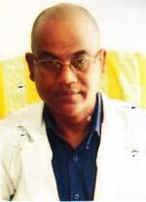 | DR. SHYAMAL KRISHNA HOWLADER  F/Name: Late Jagneswar Howlader  M/Name: Late Sukhoda Rani Howlader  BM & DC Reg. No: 14515  NID: 4214331596743  Cell: 01712163530  Address: UHC, Mirjagonj, Patuakhali  Blood Group: B+
17 | Voter No  LM-5200017 | DR. SALMA AKHTER  F/Name: Md. Harun Or Roshid  M/Name: Mrs. Minuka Harun  BM & DC Reg. No: 65854  NID:  Cell: 01758659348  Address: 530, Gulshan Bhabon, College Road, Patuakhali  Blood Group: O+
18 | Voter No  LM-5200018 | DR. MD. JASIM UDDIN MUKUL  F/Name: Md. Jalal Uddin Mia  M/Name: Ayesha Siddika  BM & DC Reg. No: 17692  NID: 7829507123139  Cell: 01712125704  Address: PTI Road, Patuakhali  Blood Group: O+
19 | Voter No  LM-5200019  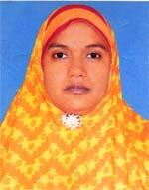 | DR. MOSAMMAT FERDOUSI AKTER  F/Name: Md. Abdul Gani Hang  M/Name: Hanufa Begum  BM & DC Reg. No: 34009  NID: 6414774923413  Cell: 01712805420  Address: Doctors Quarter, 250 Beded Hospital, Patukhali  Blood Group: O+
20 | Voter No  LM-5200020  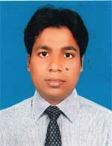 | DR. MD. HABIBUR RAHMAN  F/Name: MD. SHAFIQUL ISLAM  M/Name: MANOWARA BEGUM  BM & DC Reg. No: 65121  NID: 19887815519095619  Cell: 01717254172  Address: C/o. Md. Shafiqul Islam Shikdar Vila, Vill- Jalisha, PO.: Dhumki, Patuakhali.  Blood Group: B+

